**HUSTLE4WORK**

Team Members:

1. Rutvik Gandhi
2. Shivam Patel
3. Ankush Chaudhary

Team Number: 03

Course Code : PROG8225

Mentors Name  
Noman Atique

13/10/23

Contents

Use Case Description: 3

Use Case Diagram 6

Analysis level(Domain) Class Diagram: 7

System Sequence Diagram: 8

State Chart Diagram: 10

Working Code Demonstration 11

## Use Case Description:

|  |  |
| --- | --- |
| Use Case Number | UC01 |
| Use Case Name | Look up Item Availability |
| Scenario | A user wants to create a new account on the website |
| Actor | Job Seeker or Employer |
| Preconditions | The User must be a logged into the system. |
| Post-Conditions | 1. based on the search parameters, the user has learned about the availability of objects. |
| Related Use Case | None |
| Stakeholders | Inventory Managers, Users |

|  |  |
| --- | --- |
| Use Case Number | UC02 |
| Use Case Name | Product report |
| Scenario | Within the system, an authorized user must create a certain report. |
| Actor | System Administration, Manager |
| Preconditions | To access and produce reports, the user must have the relevant rights. |
| Post-Conditions | 1. The requested report is delivered to the user. |
| Related Use Case | None |
| Stakeholders | Management, Analysis |

|  |  |
| --- | --- |
| Use Case Number | UC03 |
| Use Case Name | Register as a job Seeker |
| Scenario | A user wants to create a user profile page when he has logged in |
| Actor | New User |
| Preconditions | 1. The user must not have an existing Job Seeker account. |
| Post-Conditions | 1. The user successfully registers as a Job Seeker. |
| Related Use Case | View user profile |
| Stakeholders | New Users, HR Managers |

|  |  |
| --- | --- |
| Use Case Number | UC04 |
| Use Case Name | Register as an Employer |
| Scenario | A new user would like to set up an Employer account in the system. |
| Actor | New User |
| Preconditions | The user must not already have an Employer account registered. |
| Post-Conditions | The user opens an Employer account successfully. |
| Related Use Case | Update Employer Profile |
| Stakeholders | New Users, Hiring Managers |

|  |  |
| --- | --- |
| Use Case Number | UC05 |
| Use Case Name | Update job seeker profile |
| Scenario | A job seeker wants to update their profile information in the system |
| Actor | Job Seeker |
| Preconditions | 1. The user must be logged into their job seeker account |
| Post-Conditions | 1. The user’s profile information is successfully updated |
| Related Use Case | Register as a job seeker |
| Stakeholders | Job Seeker, HR Managers |

|  |  |
| --- | --- |
| Use Case Number | UC06 |
| Use Case Name | Update Employer Profile |
| Scenario | An Employer wants to update their company profile information in the system. |
| Actor | Employer |
| Preconditions | 1. The User must be logged into their Employer account |
| Post-Conditions | 1. The User’s company profile information is successfully updated |
| Related Use Case | Register as an Employer |
| Stakeholders | Employers, Company Representatives |

|  |  |
| --- | --- |
| Use Case Number | UC07 |
| Use Case Name | Search for jobs |
| Scenario | A job Seeker wants to search for available jobs in the system. |
| Actor | Job Seeker |
| Preconditions | 1. The User must be logged into their job seeker account |
| Post-Conditions | The user receives a list of relevant job listing based on the search criteria. |
| Related Use Case | Apply for a job |
| Stakeholders | Job Seekers, Hiring Managers |

|  |  |
| --- | --- |
| Use Case Number | UC08 |
| Use Case Name | Post a job |
| Scenario | An Employer wants to create and post a new job listing in the system. |
| Actor | Employer |
| Preconditions | 1. The user must be logged into their Employer account |
| Post-Conditions | A new job listing is successfully posted in the system |
| Related Use Case | Update job listing |
| Stakeholders | Employers, HR Managers |

|  |  |
| --- | --- |
| Use Case Number | UC09 |
| Use Case Name | Apply for a job |
| Scenario | A Job Seeker wants to submit an application for a specific job listing |
| Actor | Job Seekers |
| Preconditions | 1. The user must be logged into their job Seeker account |
| Post-Conditions | The user’s application is successfully submitted for the selected job listing. |
| Related Use Case | Search for Jobs |
| Stakeholders | Job Seekers, Hiring Managers |

|  |  |
| --- | --- |
| Use Case Number | UC10 |
| Use Case Name | Update job listing |
| Scenario | An Employer wants to update an existing job listing in the system. |
| Actor | Employer |
| Preconditions | The user must be logged into their Employer account. |
| Post-Conditions | The job listing is successfully updated in the system |
| Related Use Case | Post a job |
| Stakeholders | Employers, HR Managers |

## Use Case Diagram

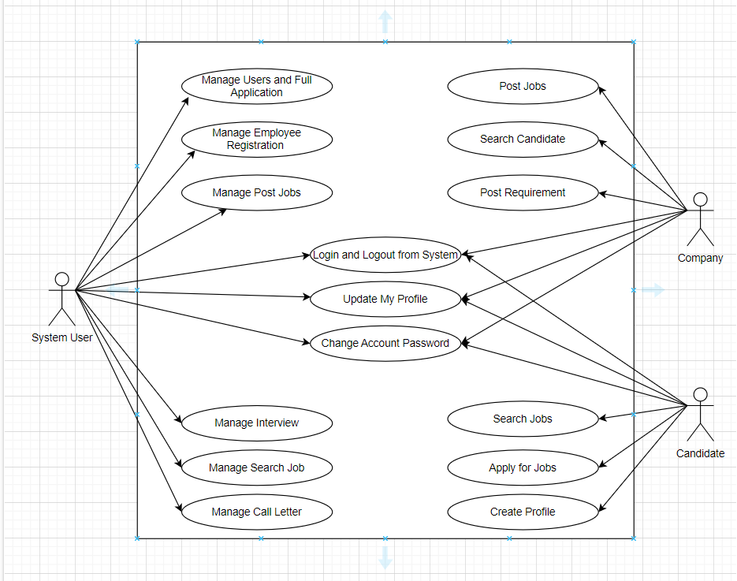

## Analysis level(Domain) Class Diagram:

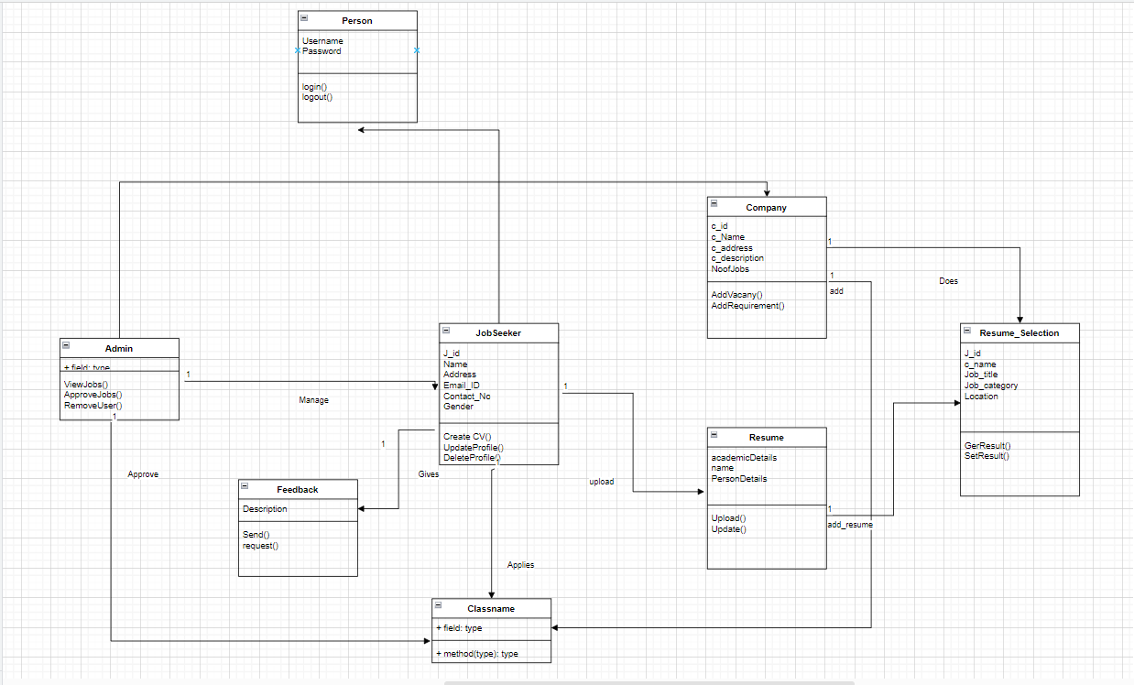

## System Sequence Diagram:

## State Chart Diagram:

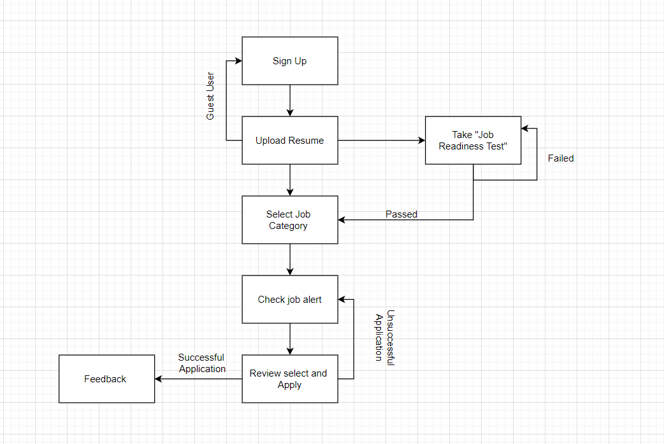

## Working Code Demonstration

1. <https://conestogac.zoom.us/rec/share/_G4KcdO-yCWRU2wRrl6MSivbNbZSiHDZTU0icz3nDcbsPuaOn3iV-JNU9OH0ysmh.hkzhhSWO9544EggM>